CONTINUOUS QUALITY IMPROVEMENT
FREQUENTLY ASKED QUESTION

What is the NT CQI Strategy
The NT CQI Strategy – initially funded by the Commonwealth under the Expanding Health Services Delivery Initiative (EHSDI), but now funded under the Stronger Futures Initiative – aims to develop and implement an NT wide Clinical CQI Strategy for all Aboriginal Primary Health Care organisations – both Aboriginal Community Controlled and NT Government.

- The aim of the CQI Strategy is to embed CQI across Aboriginal Primary Health Care in the Northern Territory.
- To ensure CQI is core business for every Primary Health care service.
- To make CQI Everybody’s business!

The NT CQI Strategy will provide opportunities for shared learning around CQI techniques and the use of CQI tools, across health services thought teleconferences, regional workshops, newsletters and a CQI website.

Does the NT CQI Strategy have a Governance Structure?

The CQI Steering Committee provides leadership to the Strategy and reports to the NT Aboriginal Health Forum (NT AHF). The CQI Steering Committee members include the General Manager of Primary Health Care, Top End Health Services, NT Department of Health, AMSANT Public Health Medical Officer, AMSANT CQI Program Coordinators, primary health care providers from both Aboriginal Community Controlled Health Services and NT Government Health Services and an Indigenous & Rural Health Division representative from Department of Health.
Two CQI Program Coordinators based at AMSANT – Top End and Central Australia – support and promote the NT CQI Strategy across the NT Aboriginal PHC services and provide mentoring and training in CQI knowledge and skills to the CQI Facilitators employed in each Health Service Delivery Area.

What components make up the NT CQI Strategy?
The original CQI Approach was developed by the CQI Planning Committee in 2009 using information from a Needs Analysis and the knowledge and expertise within the group. It was endorsed by the NT AHF In November 2009.
In 2012/13 the NT CQI Strategy underwent an evaluation by Allen+Clarke. In response to the recommendations made, the NT CQI Strategy Model was workshopped by the CQI Steering Committee and updated I June 2014. The elements of the current NT CQI Strategy encompass the principles, framework and elements of the original model along with newer elements to cover the wider definition of CQI in the Northern Territory.

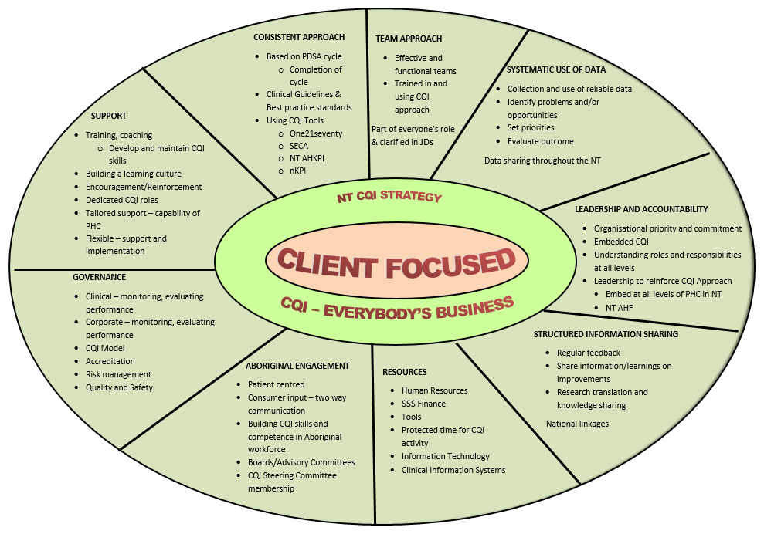

Link Executive Summary – NT CQI Approach
……………………………..

Link NT CQI Strategy Evaluation
……………………………………..

What kind of support will we get through the NT CQI Strategy?

Two CQI Program Coordinators provide leadership and expertise in CQI. Their role is to work with the CQI Steering Committee to develop and implement a clinical CQI approach, coordinate the preparation and provision of regional training, workshops, and peer support on CQI for clinicians, and to mentor and train the CQI Facilitators.

CQI Facilitators have been allocated to each HSDA and will work with PHC staff and management. The Facilitators assist staff in mapping current quality improvement systems, identify gaps in CQI knowledge and activities, and help to develop HSDA and local plans to expand CQI capacity in line with health service objectives and standards and the endorsed CQI model for Aboriginal PHC – the NT CQI Strategy. They will also assist local staff to develop, implement and evaluate quality activities that address local needs.

The NT CQI Strategy provides a consistent but flexible framework to support CQI activities in PHC services across the NT.

What sort of training and support can we expect?

A range of training and support is available for health service staff. This includes “on the ground” support from CQI Facilitators as mentioned above, and other training workshops, e.g., CQI Collaboratives, one21seventy foundation training, Aboriginal and Torres Strait Island CQI Workshops.

What is the NT CQI Collaborative?

The aim of the CQI Collaborative is to promote an environment of shared learning. To provide clinicians and other health service staff with an opportunity to come together to consider ways to use their data to improve their clinical systems through the use of continuous quality improvement processes with the aim of improving health outcomes of our patients.
2014 saw the introduction of Regional CQI Collaboratives. Regional CQI Collaboratives allow health services the opportunity to focus on issues that are of relevance and importance to them. These day long workshops have given greater numbers of staff the opportunity to attend, and also allowed them to contribute to strategies that will improve systems and processes that support good quality health care in their local areas. Working in teams and using CQI tools along with their own data has seen a greater personal investment by members of the service.

Who can attend the CQI Collaboratives?

Any clinician or other health service staff working in Aboriginal PHC in the NT – both government and Community Controlled Health Services can attend the CQI Collaboratives.

Who is involved in CQI?

The aim of the NT CQI Strategy is to embed CQI across the whole PHC team. CQI is everybody’s business to work within a quality framework and to participate in quality activities. One person in a health service cannot do all the work and although there will be CQI Facilitators to provide hands on assistance and support, each member of the staff should be actively involved and participating in CQI.

How can we get our staff involved?

- Staff should be engaged every step of the way. A good way to ensure that they are engaged in the process is to keep them informed about what is happening and involve them in planning
- Provide staff with updated information on the NT AH KPI reports and planned CQI activities
- Have CQI on the agenda at your regular clinic meetings to discuss current or planned CQI activities, get input from the team during these meetings and make decisions about CQI activities together, use CQI tools like PDSA – plan, do, study, act – to plan for change, document, problem solve, identify responsibilities, etc.
- Orient new staff to your CQI activities and the role they will be expected to play
- Get feedback from staff. They will have some great ideas to share!
- Reward achievements – take time to celebrate the big and the little successes. This will keep staff motivated and engaged
- Document changes in roles and processes to embed new systems

How can we build understanding around using data to drive and support CQI?

- Engage staff in the reporting process – make them aware of the specific indicators being reported on, share the report when it is sent back to the clinic, have full team participation in the analysis of the data.
- Work with the health service team to analyse the data from such reports as the NT AHKPIs, the nKPIs, one21seventy. Look at the report and ask “what is the data telling us?”
- Use the data from reports to identify areas of achievement – what are you doing well? Celebrate these good outcomes.
- Use the data from reports to identify areas that need improvement and work as a team in planning CQI activities.

What role do Aboriginal Health Practitioners have in CQI?

All staff in the health service should be involved in CQI activities. Aboriginal staff – AHP, AHW, Administration staff, Drivers, Cleaners – are often local people and are the staff who stay at the health service for the longest. This makes them particularly important in CQI as they may well be the key to sustainability and meaningful engagement with the wider community.
Mentoring and training AHPs in CQI knowledge and skills will ensure their capacity to be fully involved and add real value to the quality activities undertaken in each service.
Specific CQI training – to increase knowledge and confidence to actively participate in CQI activities – is provided for ATSI health service staff.

How does data support CQI?

Without data it is impossible to know whether you have actually improved. The data you collect will help to inform whether the changes you are making are actually leading to improvement.

Data enables you to monitor your results over time allowing you to:
- Identify areas that need improvement
- Identify areas where performance seems to be getting weaker
- Identify targets for CQI activities
- Monitor whether changes to systems or processes are making a difference
- Gather evidence that change has led to improvement. This can be shared with CEOs, Boards and community members
- Support funding submissions

How can our service get the most value out of our data?

It is important to see data as a tool to support and guide CQI activities rather than become an instrument of blame. Data shows where you are doing well and where more effort or change is required.

- Make sure that data collection is well planned and well administered
- Ensure that you analyse your reports thoughtfully to identify areas of strength and weakness
- Understand the principle of data cleansing – ‘garbage in, garbage out”
- Use the data to set improvement targets for following years
- Work with your management and team to decide what kind of changes you need to make so performance improves
- Look for benchmarking opportunities with other services in your region to compare results
- Consider where your health team may need professional development or up-skilling

What is benchmarking?

Benchmarking enables health services to compare and discuss their data or reports with other health services, either in their region or on a NT or national level.
Benchmarking supports the sharing of ideas about delivering quality health services.

What is data cleansing?

Data cleansing is about ensuring that data entered into your Clinical Information System (CIS) is as accurate as possible and that information is entered in to the correct files in your CIS. Accurate data entry, consistent use, planned regular review and ‘clean up’ of the data base will increase accuracy and your reports.

Data cleansing includes:

- Accurate coding of patients – current, transient, past
- Consistent diagnosis of chronic conditions across the service
- Ensuring that clinical items, e.g., BP, weight, BMI, etc. are recorded in the correct location
- The downloading of pathology

What is PDSA?

A PDSA (plan – do – study – act) is a small scale, rapid cycle process of change. It can be used to test change ideas before implementation on a wider scale. The PDSA is a proved process intended to improve quality of care in incremental and manageable stages.

