CQI Tools and Resources Project
PDSA Template
June 2016

Contents
Acknowledgments 3
Introduction 4
Template 5
PDSA Cycle Microsoft Word Template 6
Plan 6
Do 7
Study 8
Act 9

Acknowledgments

The Project
The CQI Tools and Resources project was commissioned by the Australian Government Department of Health (Indigenous Health Division) to support the National Continuous Quality Improvement Framework for Aboriginal and Torres Strait Islander Primary Health Care. The project was conducted by the Lowitja Institute, together with a Project Team of representatives from partner organisations, NACCHO and each state and territory peak body, with advice from a project Technical Panel of experts in CQI in the Aboriginal community controlled health sector.
Development Team
The PDSA Template was developed by the ThinkThrough team led by Dr Sanchia Shibasaki and Dr Beverly Sibthorpe with contributions from Dr Jacki Mein, Ms Kerry Copley, and Ms Carolyn Renehan.

Introduction
Plan-Do-Study-Act (PDSA) cycles are identified in the CQI Framework as the key CQI strategy (C7). There is an expectation that services will be able to demonstrate that they are implementing PDSA cycles on a routine basis.
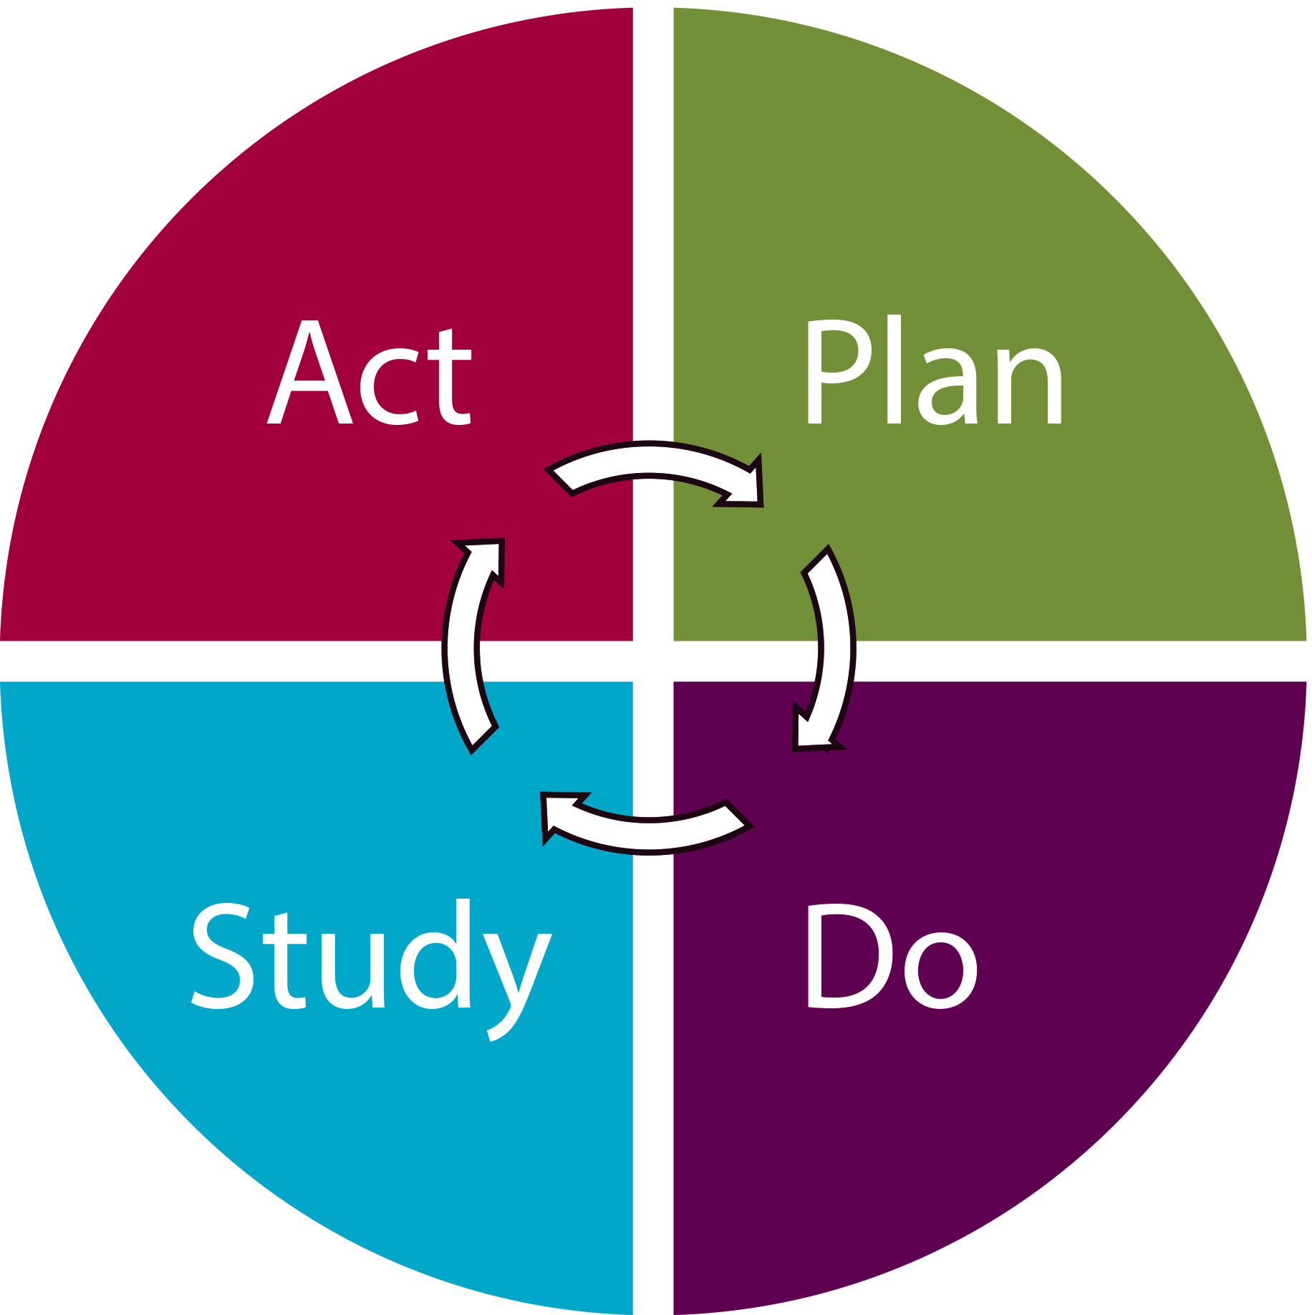
PDSA cycles involve teams using measurement and problem solving to identify sources of variation in care processes and outcomes, to design and test strategies for improvement and implement change. PDSA is conducted in rapid cycles that typically happen over short periods such as fortnightly or monthly but longer cycles can also be used.

Many different techniques for conducting PDSA now exist in health care settings – they all share a common set of principles and practices (Langley & Nolan 1992).
Principles and practices for conducting PDSA cycles
- Take a simple approach
- Start small
- Help to plan, develop and implement change that can lead to improvement
- Involve the whole team in redesigning health systems and care processes to achieve improvements
- Engage teams in a continuous and incremental stream of improvements over time.
Langley, G., Nolan, K. & Nolan, T. 1994, ‘The foundation of improvement’, Quality Progress, vol.27, no.6, pp. 81–6.

Template
The desktop review and the findings from the sector consultations showed that there are a number of PDSA templates freely available, so the first problem confronting services is sorting through all the potential templates to find—and perhaps adapt—one that meets their needs. This would involve unnecessary time costs and inevitably result in a further proliferation of different templates in use across the sector. Also, none of the eight templates reviewed for this project was ideally suited to the sector. For a range of reasons, including that they were framed as very static one-off rather than rolling accounts, they required more information to be recorded than was necessary. In some instances, they included a heavy focus on predicting outcomes of the action parts of the cycle that would often be quite difficult to do.
The Microsoft Word PDSA Template developed through the CQI Tools and Resources Project is included in this document. This template is designed to be tailored to the organisation’s context and requirements. For example, the text may be changed (questions amended, deleted or added); the layout may be changed (‘plan’ and ‘do’ questions on one page and ‘study’ and ‘act’ on another page); fields may be added (date fields added to each stage of the cycle); and so on. This meets the project and sector requirement for flexibility.

PDSA Cycle Microsoft Word Template
Organisation: | Program:
Name: | Date:

PLAN
What is our issue/problem and how does it affect care and outcomes for our clients? (Be specific)
What does the current data/information show? (Baseline data - insert tables and/or graphs as appropriate)
What could we do to improve? (List all the ideas)

DO
What will we try first?
What do we want to achieve and how will we measure it? (Be specific)
What actions are we going to take? (What, who, how and when?)

STUDY
What happened? (What worked well, not so well?)
What does the follow-up data/information show? (Insert tables and/or graphs as appropriate)

ACT
What changes will we make to practice?
How are we going to do that? (What, who, how and when?)
What issues remain?
Do we need to address them in another cycle?

