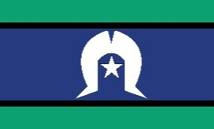
EDUCATION AND ADOPTION
Resources and events update
The Bulletin

October 2023 Issue

Digital health did you know? October is cyber security awareness month.
Cyber security awareness month is a time to remind us that there are many ways we can protect ourselves and the healthcare organisations we work for from cyber threats.
The Australian Digital Health Agency hosts a number of cyber-security podcasts to help keep you informed and prepare for cyber threats, including the latest “Data recovery tips – do you have a response plan?”. This podcast is essential listening for all healthcare providers who want to ensure they and their business can easily get back on track if their practice is compromised by a ransomware attack. It also includes a great example of how My Health Record can be particularly useful for specialists who have uploaded copies of their letters prior to a cyber-attack. You can find the Agency’s podcasts here: www.digitalhealth.gov.au/newsroom/podcasts
Alternatively, you can access free eLearning modules, including the RACGP CPD accredited Digital Health Security Awareness module and other cyber-security modules here: www.training.digitalhealth.gov.au

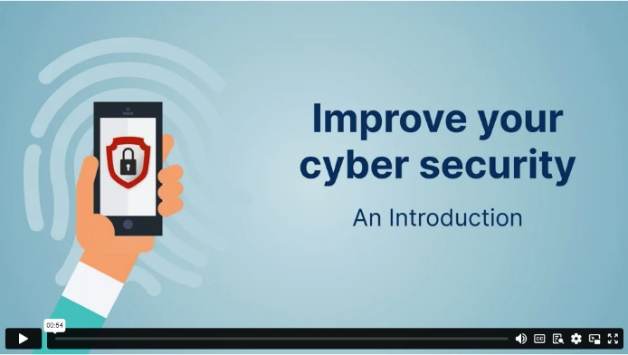
New cyber security animations

For your patients, the Agency has recently released some animations as a guide to help protect individuals and their families from cyber threats when accessing and using digital health tools.

Individuals can find tips on how to spot cyber threats and how to avoid them, along with the new animations here: www.digitalhealth.gov.au/initiatives-and-programs/cyber-security

Consultation now open: Improved sharing of pathology and diagnostic imaging information
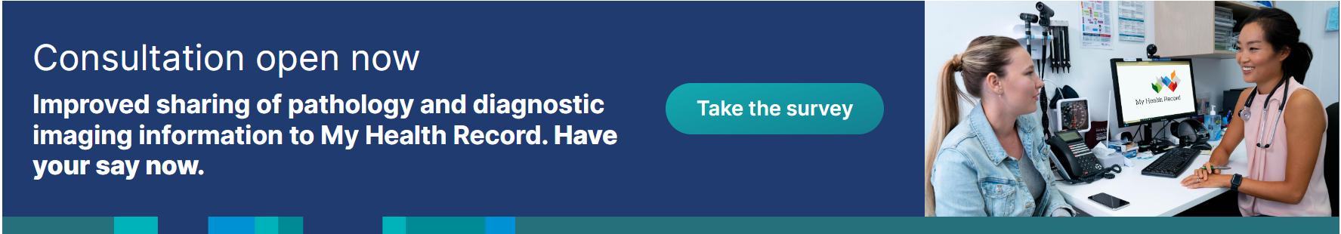

Changes are being made to improve sharing of pathology and diagnostic imaging information to My Health Record. This will help empower patients to participate in their healthcare and make it easier for healthcare providers to coordinate care and make clinical decisions.
Consultation on these changes is now open and feedback will help shape implementation.
Visit Modernising My Health Record to find out more and have your say.

Finding medicines information in My Health Record

There is a wealth of medicines information available in My Health Record, including prescription and dispense records, Pharmaceutical Benefits Scheme data and medications recorded in individual clinical documents, such as shared health summaries and discharge summaries.
My Health Record views and overviews can help you find the medicines information you need. The Medicare Overview, Medicines View or Prescription and Dispense View are examples of system-generated views which consolidate the information in a person’s record, bringing key information together on a single screen.
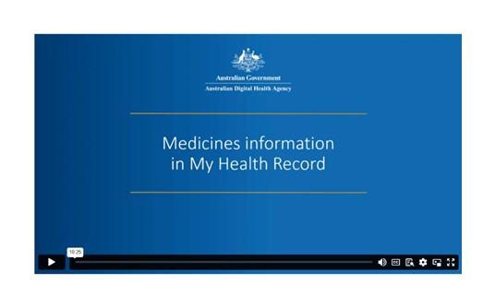Watch this short, informative video to gain an understanding of the various views and overviews that include medicines information in My Health Record and the benefits and limitations of each.
Watch video

Upcoming events for consumers

How My Health Record can support your mental health management
During Mental Health Month, learn how My Health Record can support your mental health journey.
- Date: 5th October
- Time: 12:00pm – 12:30pm AEDT
- Register

My Health Record for carers
Join this session to celebrate National Carers Week and find out more about how carers can access and manage the My Health Record of an individual.
- Date: 20th October
- Time: 12:00pm - 12:30pm AEDT
- Register

Health on the go: my health app for travellers
Join this session to learn how the my health app can help you make better decisions for your health while you travel.
- Date: 25th October
- Time: 1:00pm – 1:30pm AEDT
- Register

My Health Record and my health app: question and answer session
Join this session to discuss all things My Health Record and the my health app. This session will be a participant led open discussion to answer any questions you may have and help support you in providing further information or where to get help on your digital health journey.
- Date: 10th November
- Time: 12:00pm – 12:30pm AEDT
- Register

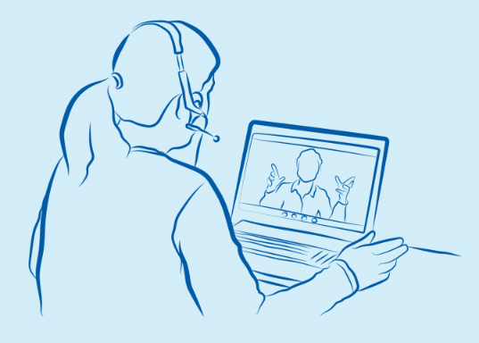
Recorded sessions
Recorded digital health online learning sessions are also available for consumers to view in their own time, at their own pace.
View recorded sessions.
Recorded sessions are also available with an Auslan interpreter.
View recorded sessions with an Auslan interpreter.

On-demand webinars for healthcare providers
Healthcare providers can now access on-demand webinars to learn about digital health in their own time, at their own pace.
.
Click on the links below to access our on-demand webinars, these are recorded sessions and will play immediately after you register or can be watched later.
Digital health series for Aboriginal Medical Services staff
- Session 1 - My Health Record for Health Workers
- Session 2 - Setting access to your My Health Record
- Session 3 - My Health Record overview documents for health workers
- Session 4 - How to access your My Health Record

Implementing Digital Health in your organisation
- Implementing a My Health Record policy in your organisation
- Digital Health Foundations Series 1 - Healthcare Identifiers and the HI service
- Digital Health Foundations Series 2 - Accessing PRODA & HPOS
- Digital Health Foundations Series 3 - Registering a Seed Organisation with the HI service
- Digital Health Foundations Series 4 - Setting up access to My Health Record and electronic prescriptions

Using My Health Record
- Easily finding the right document in My Health Record
- Making sense of My Health Record medicines information
- Using the Emergency Access function in My Health Record
- Understanding My Health Record and patient privacy

Sessions by specialty or area of practice
Events & webinars website for healthcare providers
The Australian Digital Health Agency provides a range of My Health Record education events including introductory and general sessions, practical demonstrations and sessions by area of practice. To register visit: https://www.digitalhealth.gov.au/healthcare-providers/webinars.

Contact us
For assistance, email the Education team education@digitalhealth.gov.au.

- My Health Record for hospital clinicians
- My Health Record supporting safety, quality and better care in Residential Aged Care Homes
Keep up to date.
Visit the Agency’s website to see the full range of webinar topics for consumers and healthcare providers.
Contact us.
For further information and support in relation to education and training, email the team:
- William.Namok@digitalhealth.gov.au (Digital Health Educator)
- education@digitalhealth.gov.au (Education Inbox)

